**Project 16: Capstone Project**

**Author : Nilesh Tiwari cs17b022@iittp.ac.in**

It is a temperature sensor setup. It employs machine learning and anomaly methods to maintain and detect temperature changes and sends an alert message over email(using Mailgun email services) about the problem.

**Hardware required**

* The Bolt Wifi module
* 3 female to male wire
* Temperature Sensor: LM35 sensor
* USB cable

The project progression in order of the objectives of the Capstone project are as follows.

**A. Build the circuit for temperature monitoring system, using the Bolt and LM35 sensor.**

**Connections**

**Step 1:** Hold the sensor in a manner such that you can read LM35 written on it.

**Step 2:** In this position, identify the pins of the sensor as VCC, Output and Gnd from your left to right.

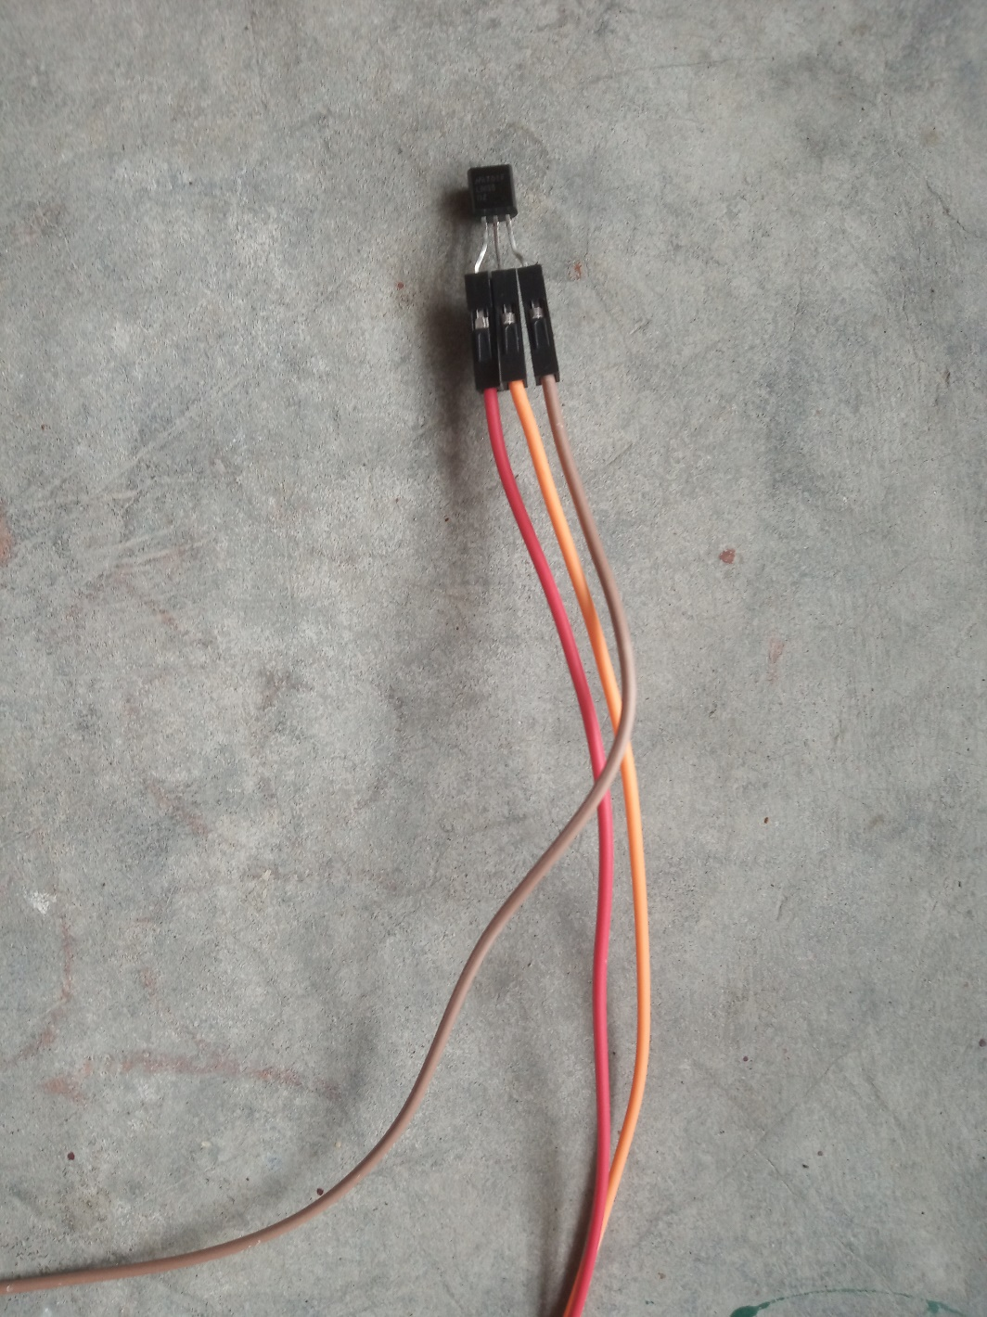

In the above image, VCC is connected to the red wire, Output is connected to the orange wire and Gnd is connected to the brown wire.

**Step 3:** Using male to female wire connect the 3 pins of the LM35 to the Bolt Wifi Module as follows:

* 1. VCC pin of the LM35 connects to 5v of the Bolt Wifi module.
  2. Output pin of the LM35 connects to A0 (Analog input pin) of the Bolt Wifi module.
  3. Gnd pin of the LM35 connects to the Gnd.

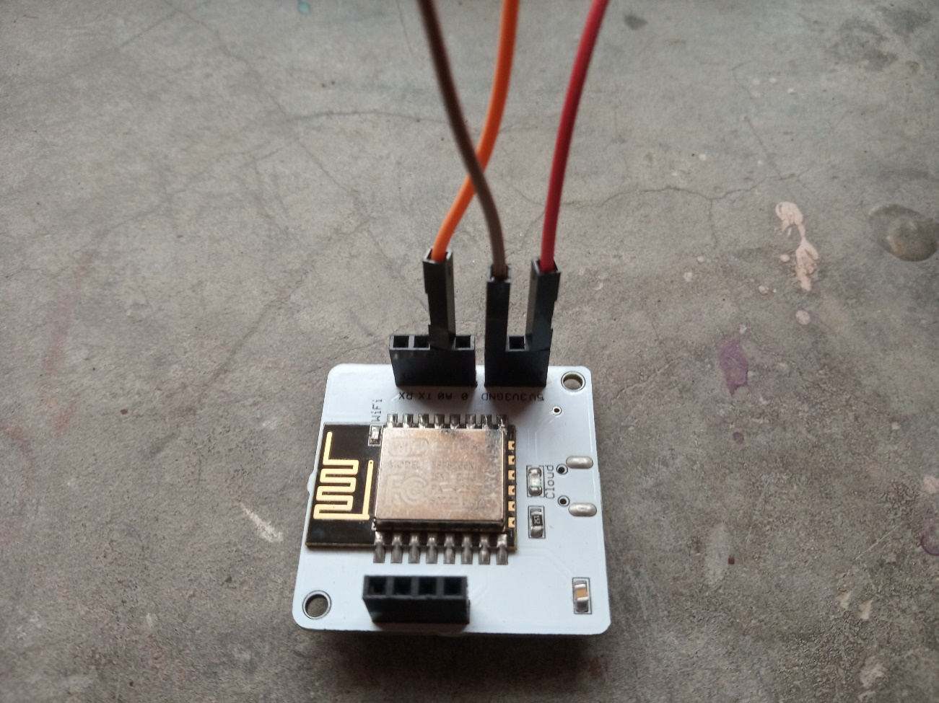

Circuit Connection

The final circuit should look like the image below:

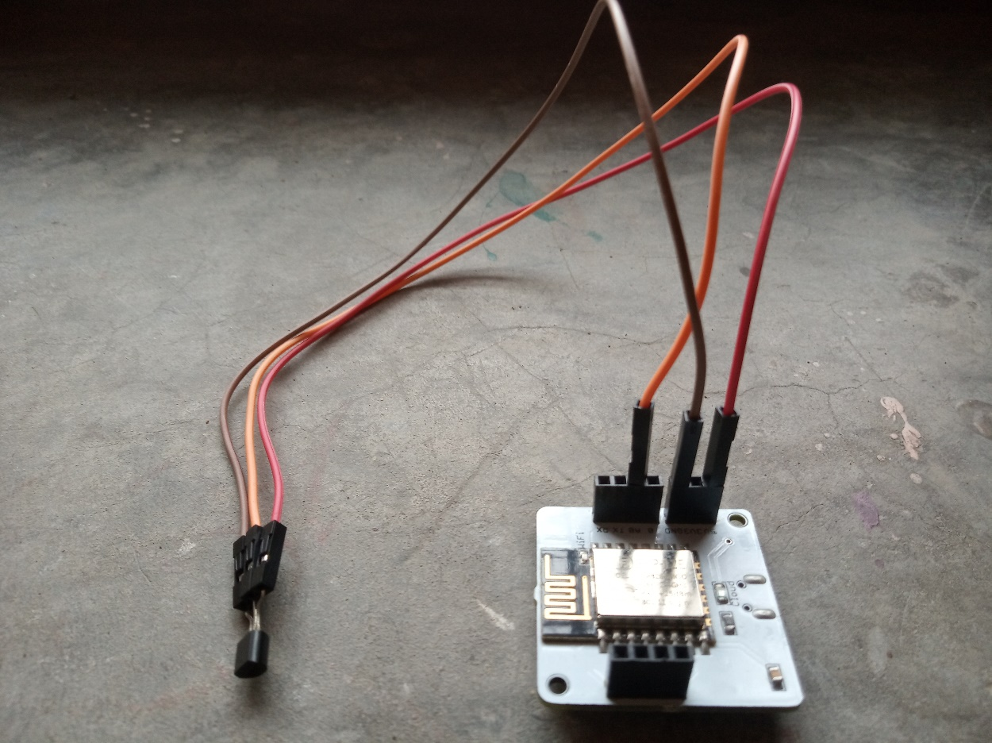

**B. Create a product on the Bolt Cloud, to monitor the data from the LM35, and link it to your Bolt.**

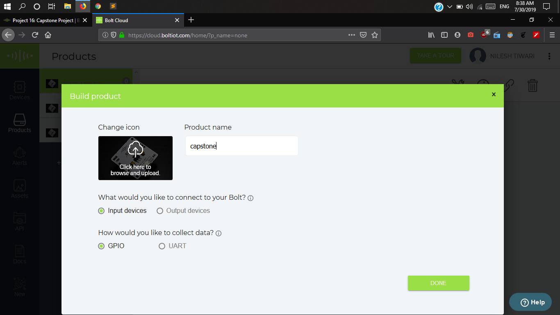

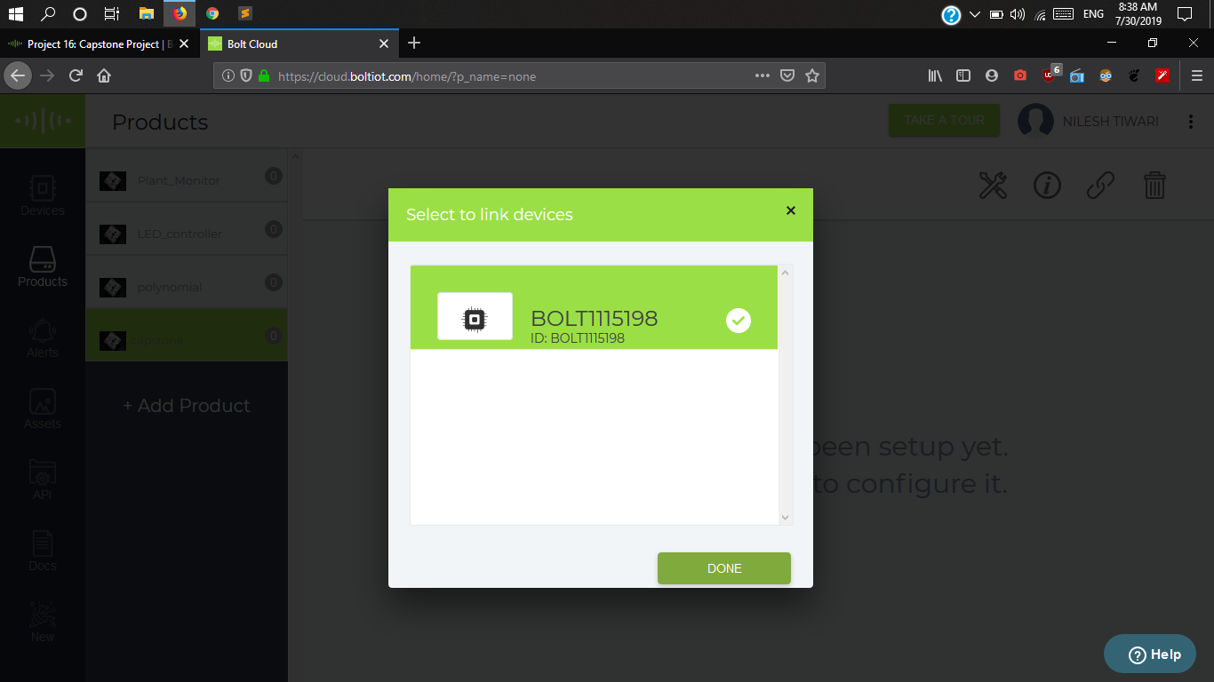

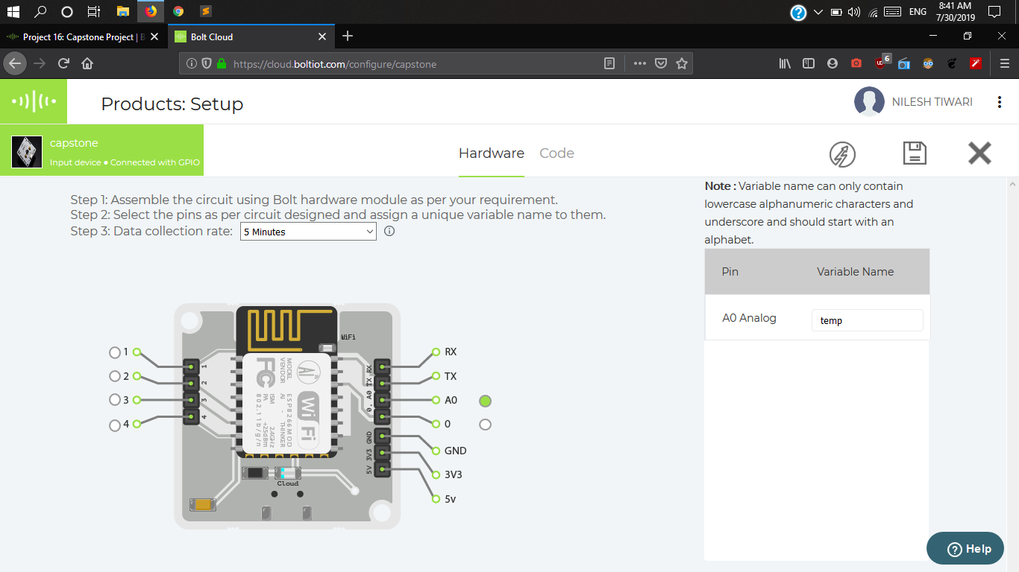

**C. Write the product code, required to run the polynomial regression algorithm on the data sent by the Bolt.**

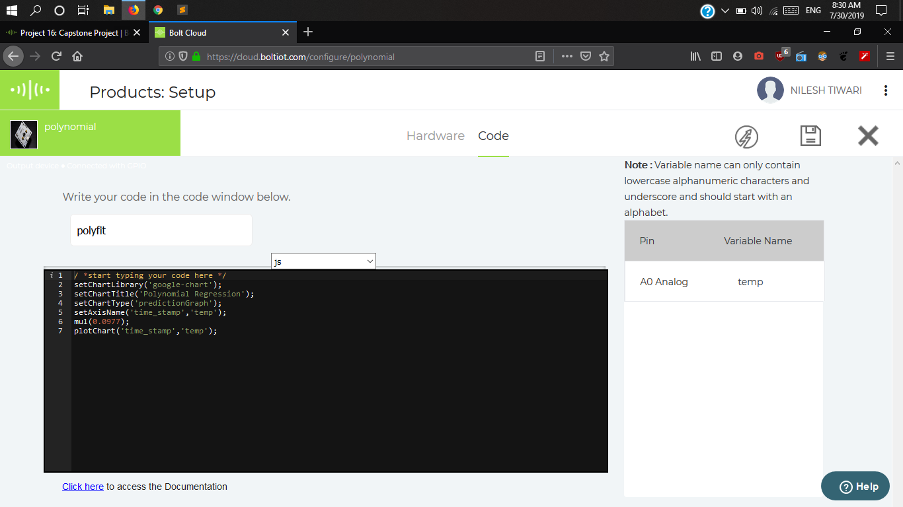

**D. Keep the temperature monitoring circuit inside your fridge with the door of the fridge closed, and let the system record the temperature readings for about 2 hours.**

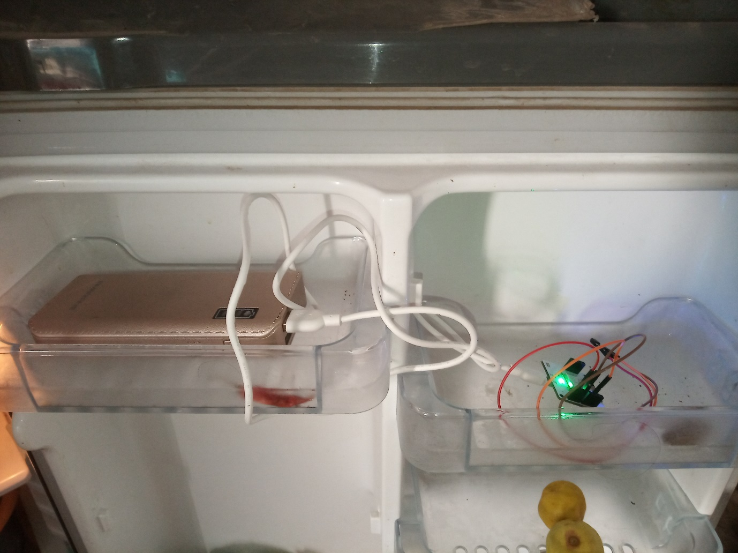

The temperature monitoring circuit kept in the fridge.

**E. Using the reading that you received in the 2 hours, set boundaries for the temperature within the fridge.**

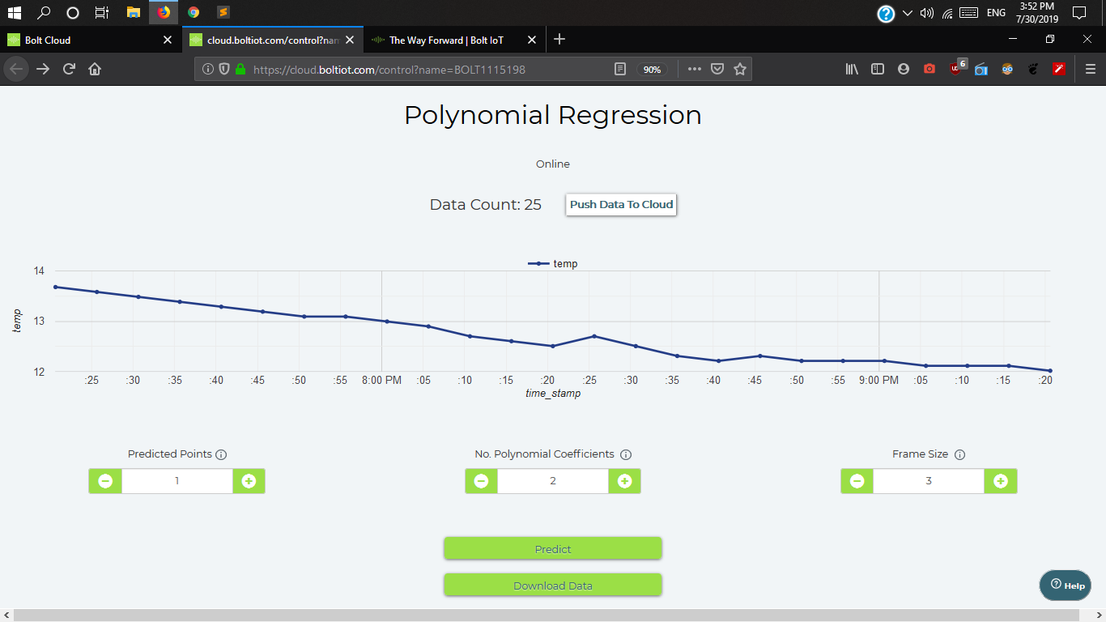

The temperature reading received in the 2 hours

The boundaries are set to 12 degree Celsius and 13.7 degree Celsius because these are the minimum and maximum temperatures inside the fridge respectively as observed from the above chart between temperature and time.

**F. Write a python code which will fetch the temperature data, every 10 seconds, and send out an email alert, if the temperature goes beyond the temperature thresholds you decided on in objective "E".**

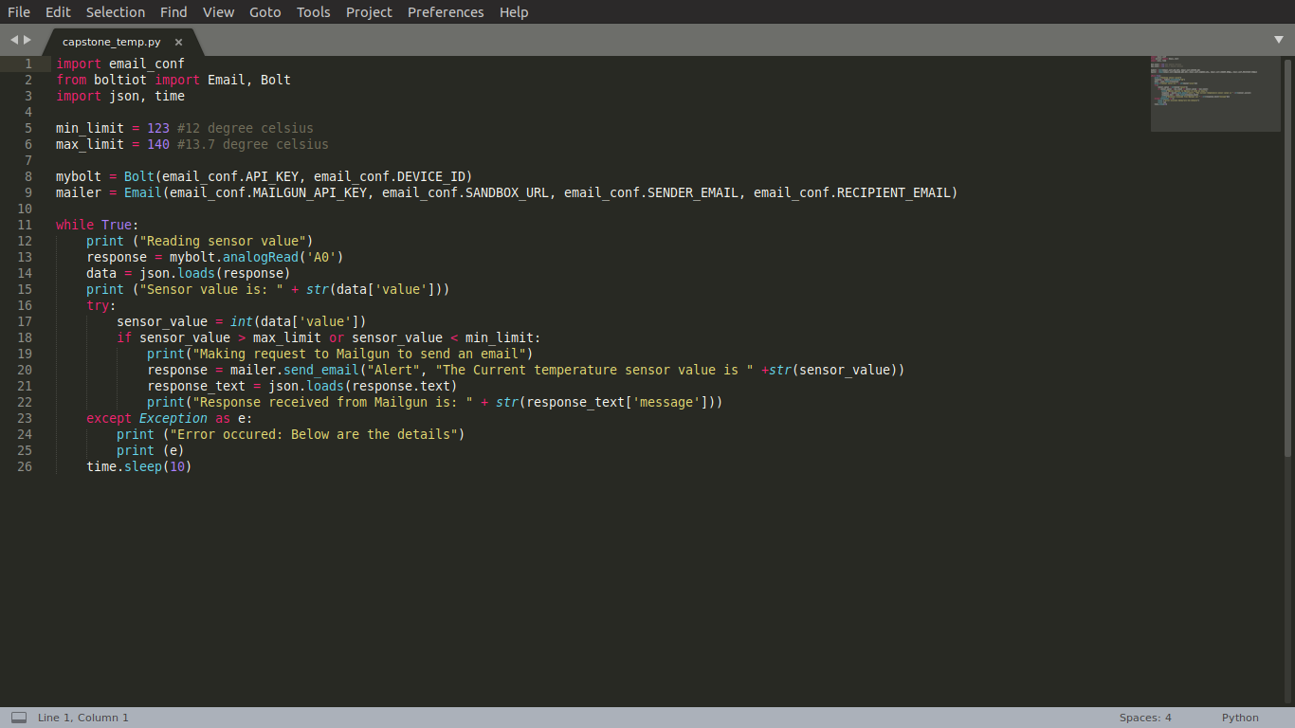

The python code for the objective F

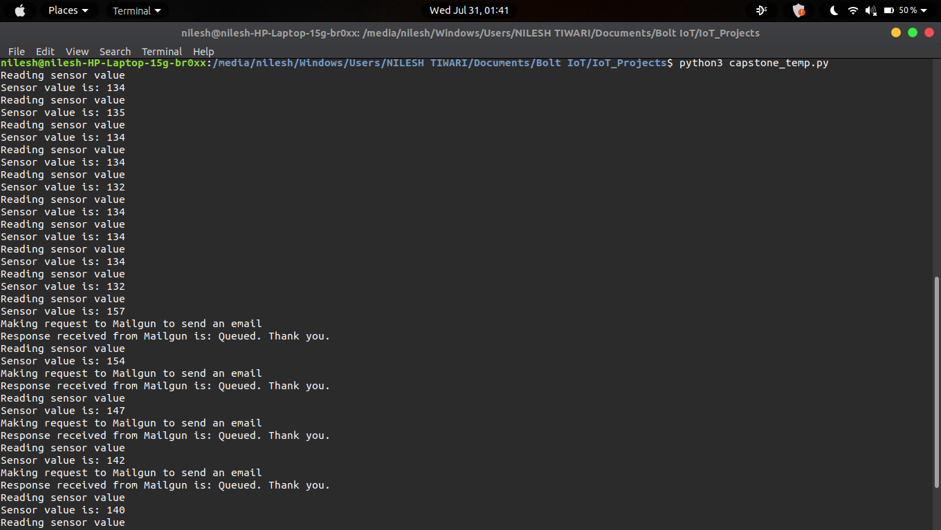

The output of the program in execution.

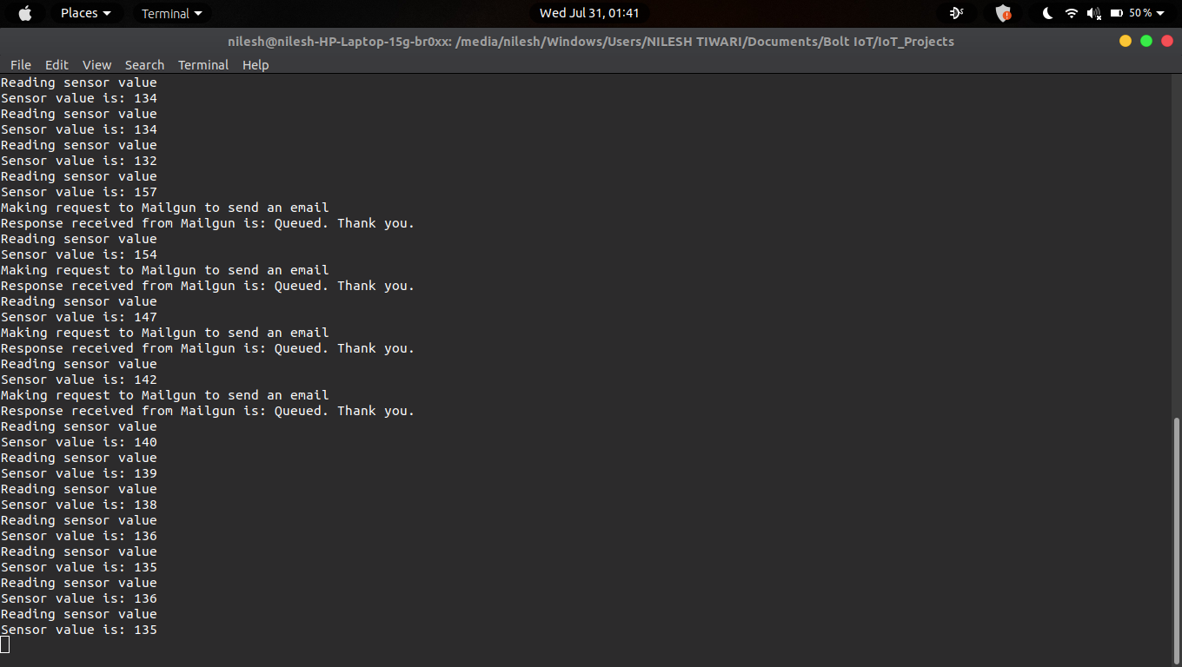

The output of the program in execution.

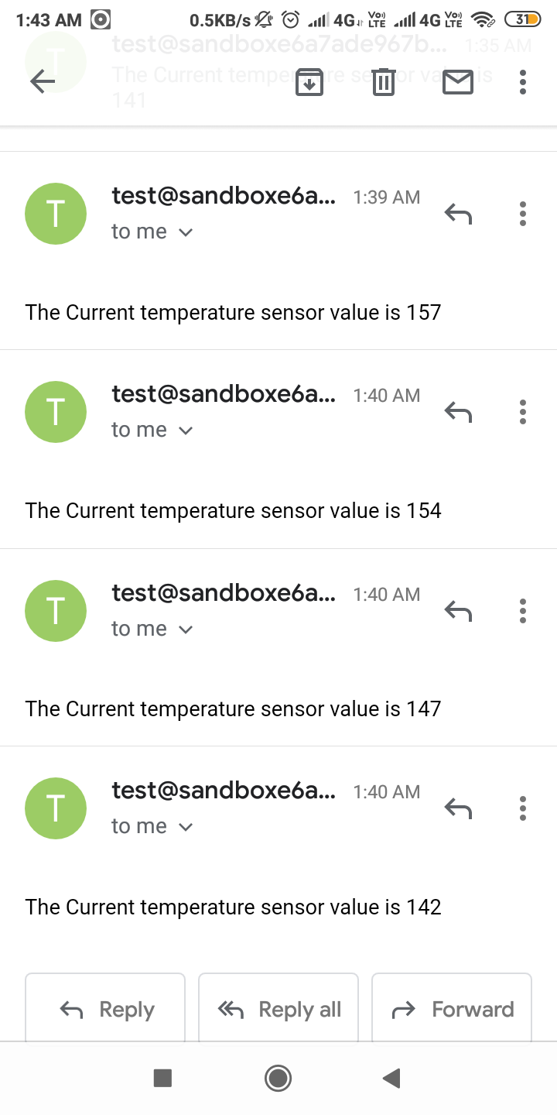

The emails received when the temperature went beyond the temperature thresholds

**G. Modify the python code, to also do a Z-score analysis and print the line “Someone has opened the fridge door” when an anomaly is detected.**

Here, conf.FRAME_SIZE = 10 and conf.MUL_FACTOR = 2.

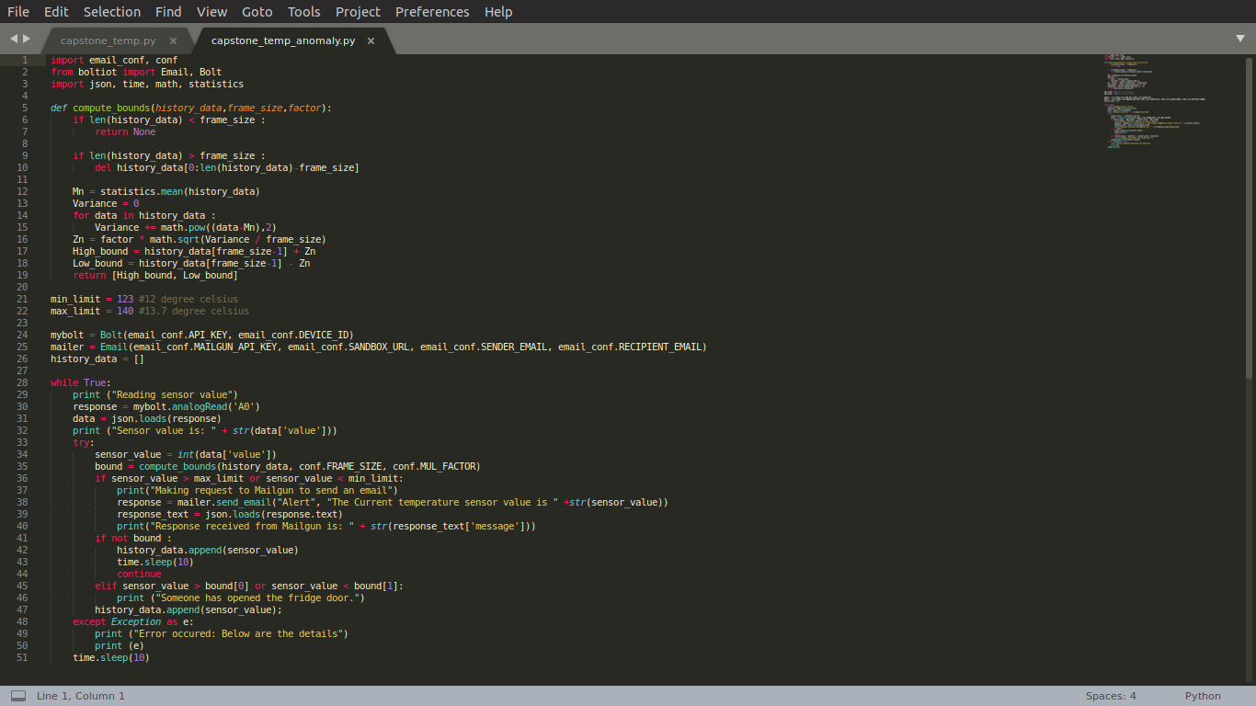

The python code for the objective G

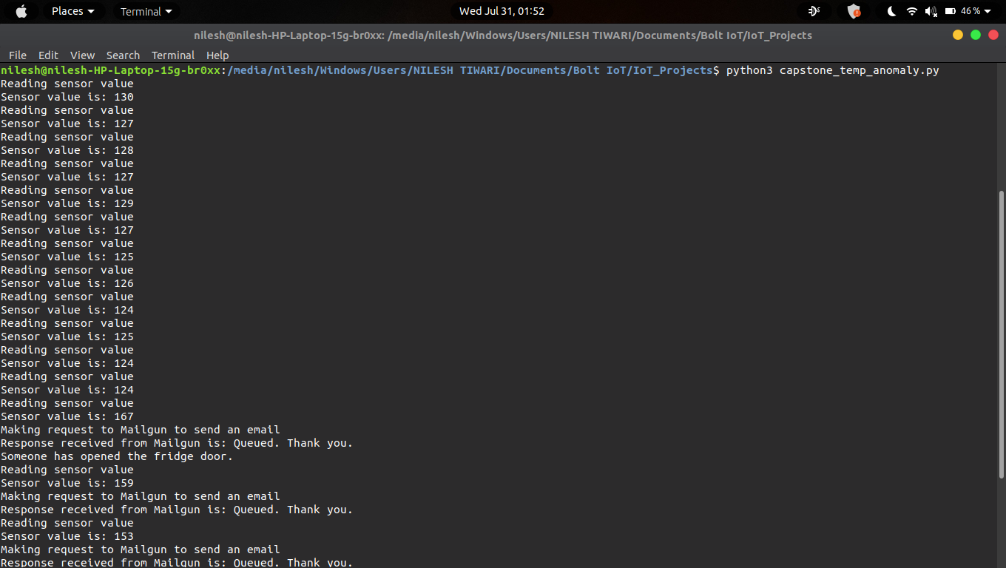

The output of the program in execution.

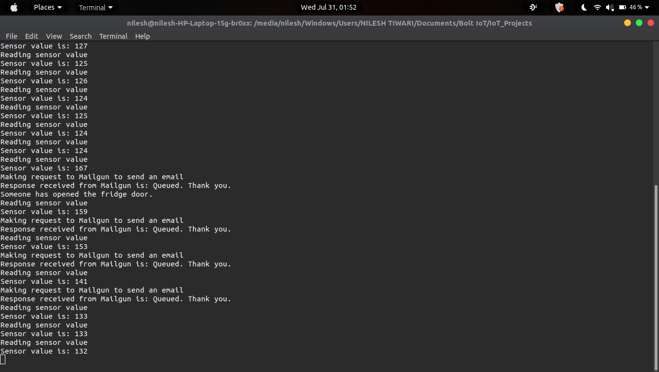

The output of the program in execution.

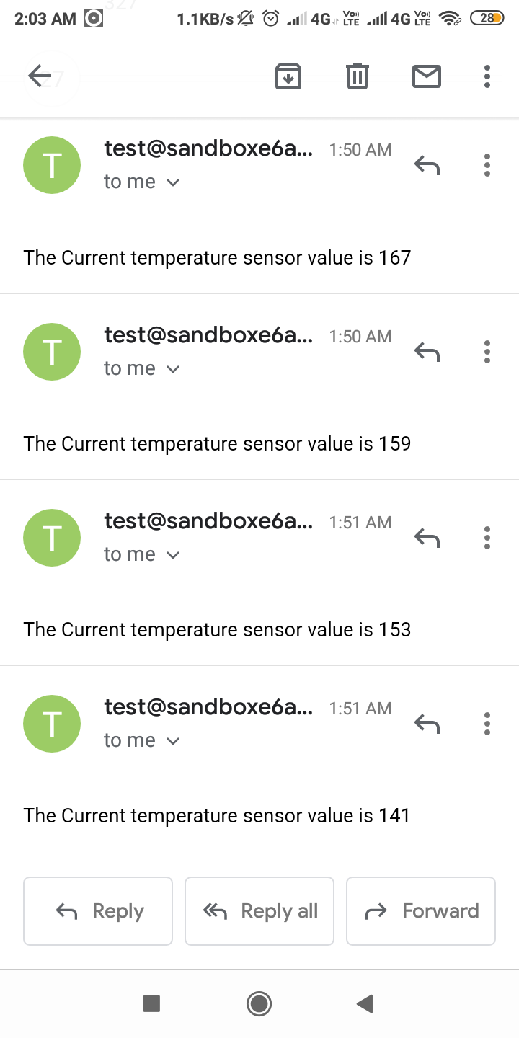

The emails received when the temperature went beyond the temperature thresholds

**H. Tune the Z-score analysis code, such that, it detects an anomaly when someone opens the door of the fridge.**

After tuning, conf.FRAME_SIZE = 10 and conf.MUL_FACTOR = 3.

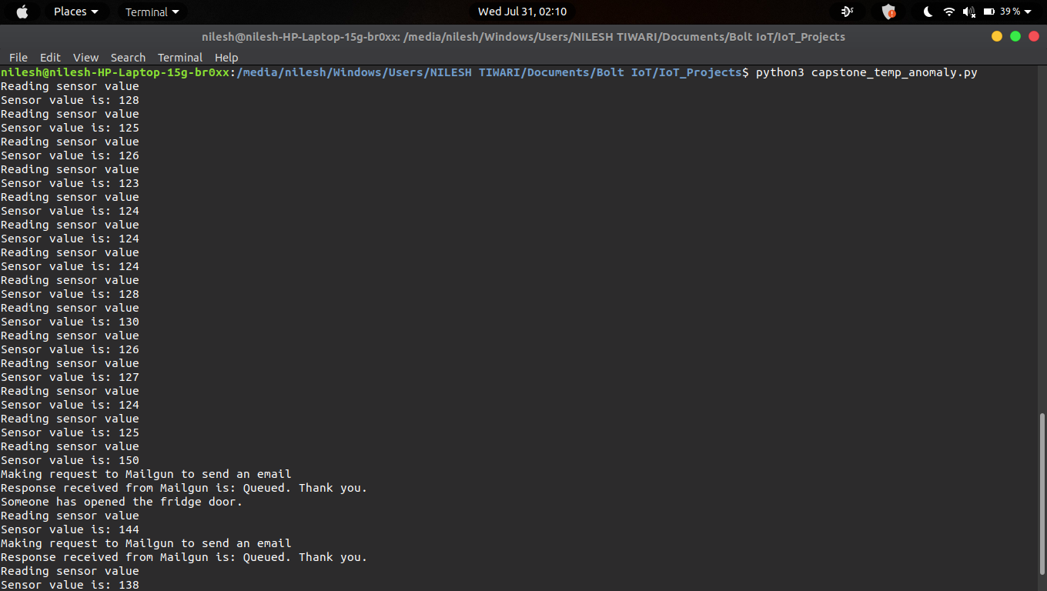

The output of the program in execution.

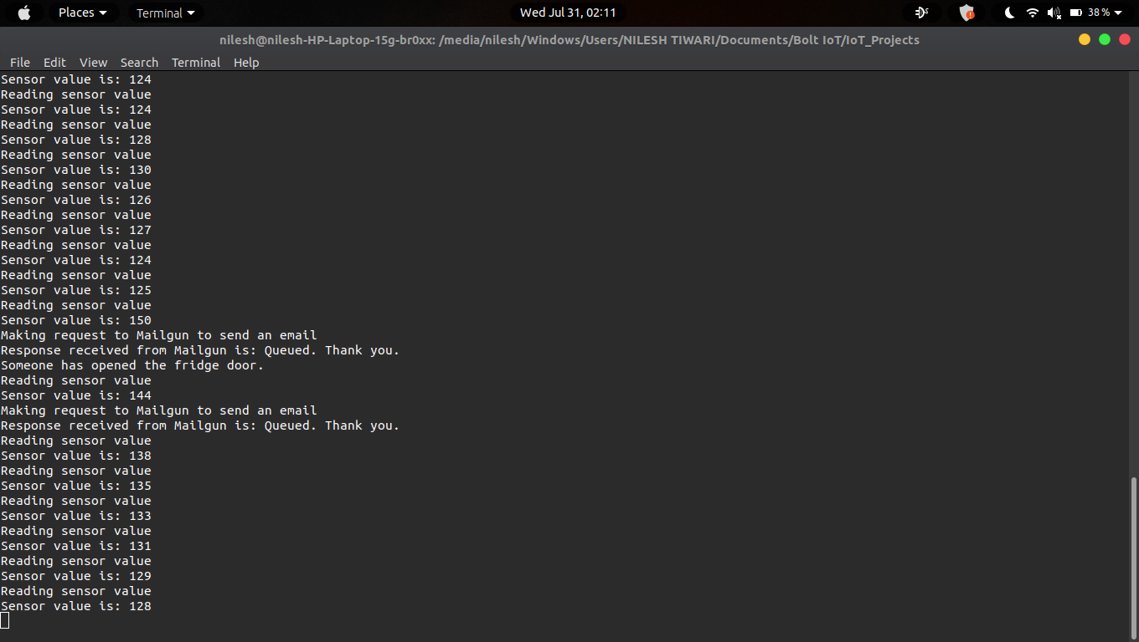

The output of the program in execution.

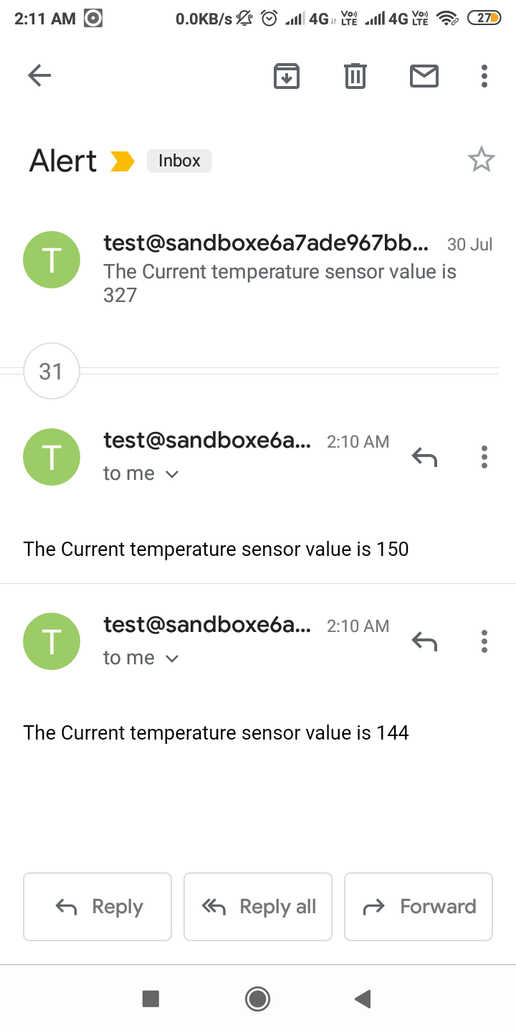

The emails received when the temperature went beyond the temperature thresholds